bottom

## WK1

* Tue lect:

#include "RIMS.h"

int main() {

while(1) {

// A3 A2 A1 A0

// !A3&&!A2 || !A2&&!A1 || !A1&&!A0 !(A3&&A2) --> !A3||!A2

// Available is 0 on Ax

B0 = (!A3 && !A2) || (!A2 && !A1) || (!A1 && !A0);

}

return 0;

}

* Thu lect:

#include "RIMS.h"

int main() {

int count;

while(1) {

count = 0;

count = A0 + A1 + A2 + A3 + A4 + A5 + A6 + A7;

/*

if (A0) {

count = count + 1;

}

if (A1) {

count = count + 1;

}

if (A2) ....

*/

B = count;

}

return 0;

}

#include "RIMS.h"

int main() {

while(1) {

if (A0) {

// Don't do this

// B = b00001111; // not supported

// each digit 0-15 0000 - 1111 0 1 2 ... 8 9 A B C D E F

B = 0x0F;

}

else {

B = 0xF0;

}

}

return 0;

}

#include "RIMS.h"

int main() {

int count;

while(1) {

count = 0;

count = A0 + A1 + A2 + A3 + A4 + A5 + A6 + A7;

// a B0, b B1, c B2, d B3, e B4, f B5, g B6

// 0gfe dcba

if (count == 0) {

B = 0x3F; // 0011 1111

}

else if (count == 1) {

B = 0x06; // 0000 0110

}

else if (count == 2) {

// B = ????

}

// ...

printf("%d\n", 15);

}

return 0;

}

#include "RIMS.h"

int main() {

while(1) {

// Tellers are at A1-A7, output highest 1 for 7-seg display

if (A7) {

// B = 7; 0000 0111

B = 0x07;

}

else if (A6) {

// ...

}

// ...

}

return 0;

}

## WK2

* Tue lect:

#include "RIMS.h"

int main() {

char num1 = 0;

char num2 = 0;

while(1) {

// Add A1A0 + A3A2, put result on B

num1 = A & 0x03; // Extract A1A0 into num1

num2 = (A & 0x0C) >> 2; // Extra A3A2 into num1

B = num1 + num2; // FIXME testing, remove

}

return 0;

}

#include "RIMS.h"

int main() {

char num1;

char num2;

while(1) {

// Get 3-bit num A6A5A4 into num1

//num1 = (A & 0x70) >> 4;

num1 = (A >> 4) & 0x07;

// Get 3-bit A3A2A1 into num2

//num2 = (A & 0x0E) >> 1;

num2 = (A >> 1) & 0x07;

B = num2;

}

return 0;

}

#include "RIMS.h"

int main() {

// Count 1s on A0, that's the number taken parking spots

unsigned char spotsCount = 0;

unsigned char i;

unsigned char currBit;

while(1) {

spotsCount = 0;

for (i = 0; i < 8; ++i) {

currBit = (A >> i) & 0x01;

spotsCount = spotsCount + currBit;

}

B = spotsCount;

}

return 0;

}

int main() {

// B3..B0 = A3..A0 + 1

// B7..B4 = A7..A4 - 1

char num1; // A3..A0

char num2; // A7..A4

char num2high;

char num1low;

while(1) {

num1 = A & 0x0F;

num2 = (A & 0xF0) >> 4;

num1 = num1 + 1; // Calculate values to output

num2 = num2 - 1;

// Output num1 on B3..B0, num2 on B7..B4

// B = (num2 << 4) | num1; Ouch!!!!

num1low = num1 & 0x0F;

num2high = (num2 << 4) & 0xF0;

B = num2high | num1low;

}

return 0;

}

* Thu lect:

#include "RIMS.h"

// Input dial A3-A0 -- 0-15

// Output motor B6..B0 -- 0-99

// y = (99/15) * x

#include "RIMS.h"

// Input dial A3-A0 -- 0-15

// Output motor B6..B0 -- 0-99

// y = (99/15) * x

int main() {

unsigned char dial;

unsigned char motorOutput;

while(1) {

dial = A & 0x0F;

motorOutput = (99 * dial) / 15;

motorOutput = motorOutput & 0x7F; // Clears bit 8

B = (B & 0x80) | motorOutput; // 10000000

// Uses B7 below, don't touch B7 above

}

return 0;

}

int main() {

unsigned char dial;

while(1) {

dial = A & 0x0F;

B = (99 * dial) / 15;

// B = B | 0x7F 11111111 | 01111111

// ???

// Uses B7 below, don't touch B7 above

}

return 0;

}

#include "RIMS.h"

// A0: Proximity sensor, used in a turnstyle

// For each pulse on A0, increment B

// Pulse: 0-1-0 000011111111111000000000

// Increment B ONCE per pulse

int main() {

B = 0;

while(1) {

if (A0) {

B = B + 1;

while (A0);

}

}

return 0;

}

{"globalCode":"","graphs":[{"name":"LoHi","prefix":"SM1","period":1000,"localCode":"","nodes":[{"id":"node_0","x":2.25,"y":62.01666259765625,"name":"SMStart","init":false,"dummy":true,"actions":""},{"id":"node_1","x":89.75,"y":149.51666259765625,"name":"Init","init":true,"dummy":false,"actions":"B = 0;"},{"id":"node_2","x":215.75,"y":148.51666259765625,"name":"Wait1","init":false,"dummy":false,"actions":""},{"id":"node_3","x":317.75,"y":150.51666259765625,"name":"Inc","init":false,"dummy":false,"actions":"B = B + 1;"},{"id":"node_4","x":443.75,"y":145.51666259765625,"name":"Wait0","init":false,"dummy":false,"actions":""}],"edges":[{"id":"edge_0","src":"node_0","dst":"node_1","priority":1,"actions":"","condition":"","bp1":{"x":52.25,"y":112.01666259765625},"bp2":{"x":46,"y":105.76666259765625},"bp3":{"x":46,"y":105.76666259765625},"bp4":{"x":99.75,"y":159.51666259765625}},{"id":"edge_1","src":"node_1","dst":"node_2","priority":0,"actions":"","condition":"","bp1":{"x":139.75,"y":173.51666259765625},"bp2":{"x":177.7796208947127,"y":234.37668874284847},"bp3":{"x":177.7796208947127,"y":234.37668874284847},"bp4":{"x":215.8092417894254,"y":175.2367148880407}},{"id":"edge_2","src":"node_2","dst":"node_3","priority":0,"actions":"","condition":"A0","bp1":{"x":265.75,"y":173.51666259765625},"bp2":{"x":291.8163525771681,"y":153.23042320908743},"bp3":{"x":291.8163525771681,"y":153.23042320908743},"bp4":{"x":317.88270515433624,"y":172.94418382051862}},{"id":"edge_3","src":"node_2","dst":"node_2","priority":1,"actions":"","condition":"!A0","bp1":{"x":240.75,"y":173.51666259765625},"bp2":{"x":215.75,"y":98.51666259765625},"bp3":{"x":275.75,"y":103.51666259765625},"bp4":{"x":260.75,"y":158.51666259765625}},{"id":"edge_4","src":"node_3","dst":"node_4","priority":0,"actions":"","condition":"","bp1":{"x":367.75,"y":174.51666259765625},"bp2":{"x":402.75,"y":173.68333435058594},"bp3":{"x":403.75,"y":185.68333435058594},"bp4":{"x":443.8092417894254,"y":172.2367148880407}},{"id":"edge_5","src":"node_4","dst":"node_4","priority":1,"actions":"","condition":"A0","bp1":{"x":468.75,"y":170.51666259765625},"bp2":{"x":443.75,"y":95.51666259765625},"bp3":{"x":503.75,"y":100.51666259765625},"bp4":{"x":488.75,"y":155.51666259765625}},{"id":"edge_6","src":"node_4","dst":"node_2","priority":1,"actions":"","condition":"!A0","bp1":{"x":443.75,"y":170.51666259765625},"bp2":{"x":355.75,"y":82.68333435058594},"bp3":{"x":341.75,"y":73.68333435058594},"bp4":{"x":263.5719484483115,"y":183.72247804879063}}]}]}

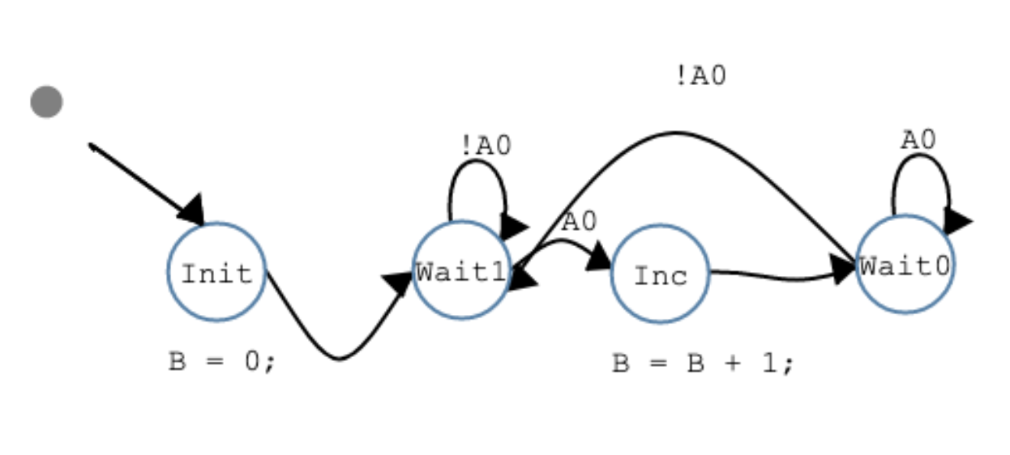

Small problem with initialization in the following code:

#include "RIMS.h"

// A0: Proximity sensor, used in a turnstyle

// For each pulse on A0, increment B

// Pulse: 0-1-0 000011111111111000000000

// Increment B ONCE per pulse

enum SM1_STATES { SM1_Init, SM1_Wait1, SM1_Inc, SM1_Wait0} SM1_STATE;

void SM1_TickFct() {

switch (SM1_STATE) {

case SM1_Init:

SM1_STATE = SM1_Wait1;

break;

case SM1_Wait1:

if (!A0) {

SM1_STATE = SM1_Wait1;

}

else {

SM1_STATE = SM1_Inc;

}

break;

case SM1_Inc:

SM1_STATE = SM1_Wait0;

break;

case SM1_Wait0:

if (A0) {

SM1_STATE = SM1_Wait0;

}

else {

SM1_STATE = SM1_Wait1;

}

break;

default:

SM1_STATE = SM1_Init;

break;

}

switch (SM1_STATE) {

case SM1_Init:

B = 0;

break;

case SM1_Wait1:

break;

case SM1_Inc:

B = B + 1;

break;

case SM1_Wait0:

break;

default:

break;

}

}

int main() {

B = 0;

SM1_STATE = SM1_Init;

while(1) {

SM1_TickFct();

}

return 0;

}

#include "RIMS.h"

// A0: Proximity sensor, used in a turnstyle

// For each pulse on A0, increment B

// Pulse: 0-1-0 000011111111111000000000

// Increment B ONCE per pulse

enum SM1_STATES { SM1_Start, SM1_Wait1, SM1_Wait0} SM1_STATE;

void SM1_TickFct() {

// Transitions (conditions / Mealy actions)

switch (SM1_STATE) {

case SM1_Start:

B = 0;

SM1_STATE = SM1_Wait1;

break;

case SM1_Wait1:

if (!A0) {

SM1_STATE = SM1_Wait1;

}

else {

B = B + 1;

SM1_STATE = SM1_Wait0;

}

break;

case SM1_Wait0:

if (A0) {

SM1_STATE = SM1_Wait0;

}

else {

SM1_STATE = SM1_Wait1;

}

break;

default:

SM1_STATE = SM1_Wait1;

break;

}

// State actions (Moore actions)

switch (SM1_STATE) {

case SM1_Wait1:

break;

case SM1_Wait0:

break;

default:

break;

}

}

int main() {

B = 0;

while(1) {

SM1_TickFct();

}

return 0;

}

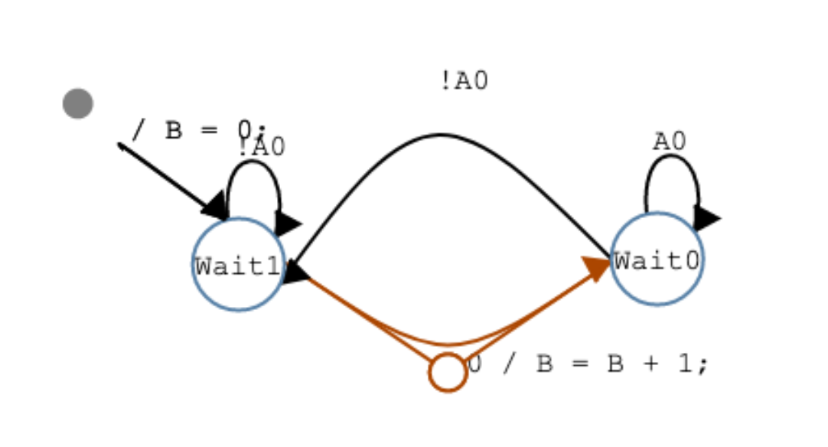

{"globalCode":"","graphs":[{"name":"LoHi","prefix":"SM1","period":1000,"localCode":"","nodes":[{"id":"node_0","x":127.5,"y":60.5,"name":"SMStart","init":false,"dummy":true,"actions":""},{"id":"node_1","x":215,"y":148,"name":"Wait1","init":true,"dummy":false,"actions":""},{"id":"node_2","x":443,"y":145,"name":"Wait0","init":false,"dummy":false,"actions":""}],"edges":[{"id":"edge_0","src":"node_1","dst":"node_1","priority":1,"actions":"","condition":"!A0","bp1":{"x":240,"y":173},"bp2":{"x":215.75,"y":98.51666259765625},"bp3":{"x":275.75,"y":103.51666259765625},"bp4":{"x":260,"y":158}},{"id":"edge_1","src":"node_2","dst":"node_2","priority":1,"actions":"","condition":"A0","bp1":{"x":468,"y":170},"bp2":{"x":443.75,"y":95.51666259765625},"bp3":{"x":503.75,"y":100.51666259765625},"bp4":{"x":488,"y":155}},{"id":"edge_2","src":"node_2","dst":"node_1","priority":1,"actions":"","condition":"!A0","bp1":{"x":443,"y":170},"bp2":{"x":355.75,"y":82.68333435058594},"bp3":{"x":341.75,"y":73.68333435058594},"bp4":{"x":262.8219484483115,"y":183.20581545113438}},{"id":"edge_3","src":"node_0","dst":"node_1","priority":1,"actions":"B = 0;","condition":"","bp1":{"x":177.5,"y":110.5},"bp2":{"x":171.25,"y":104.25},"bp3":{"x":171.25,"y":104.25},"bp4":{"x":225,"y":158}},{"id":"edge_4","src":"node_1","dst":"node_2","priority":0,"actions":"B = B + 1;","condition":"A0","bp1":{"x":265,"y":172},"bp2":{"x":354.7796208947127,"y":232.37668874284847},"bp3":{"x":354.7796208947127,"y":232.37668874284847},"bp4":{"x":443.0592417894254,"y":171.72005229038444}}]}]}

## WK3

* Tue lect:

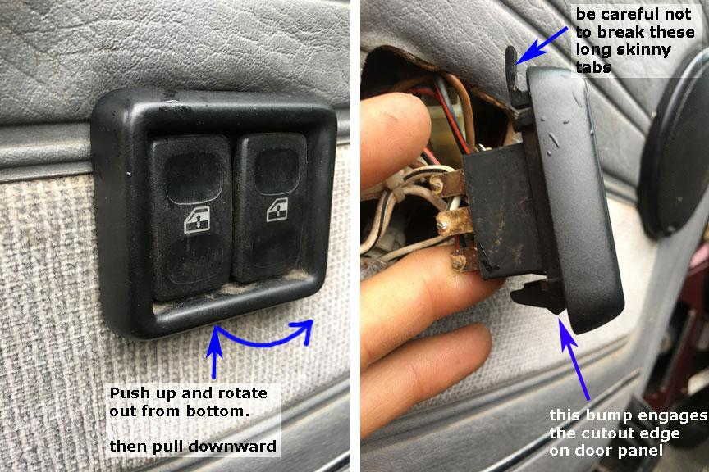

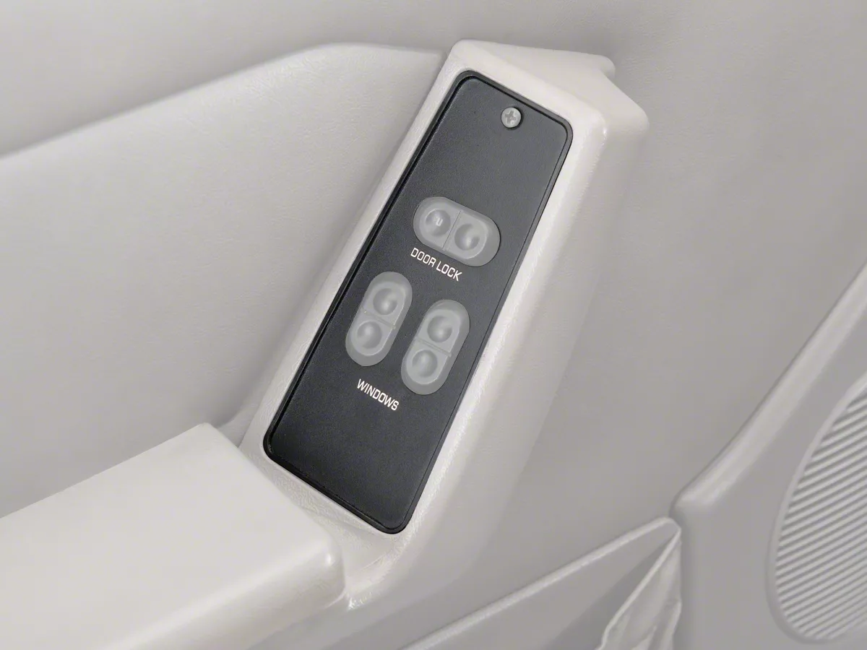

A0 = 1 Up

A1 = 1 Down

(both = 1 ignore)

A2 = 1 It's all the way up

A3 = 1 It's all the way down

B0 = 1 Power the window motor upwards

B1 = 1 Power the window motor downwards

{"globalCode":"","graphs":[{"name":"LoHi","prefix":"SM1","period":1000,"localCode":"","nodes":[{"id":"node_0","x":-1.25,"y":56.68333435058594,"name":"SMStart","init":false,"dummy":true,"actions":""},{"id":"node_1","x":86.25,"y":144.18333435058594,"name":"Wait","init":true,"dummy":false,"actions":"B0 = 0;\nB1 = 0;"},{"id":"node_2","x":384.6666717529297,"y":43.18333435058594,"name":"Up","init":false,"dummy":false,"actions":"B0 = 1;\nB1 = 0;"},{"id":"node_3","x":339,"y":222.35000610351562,"name":"Down","init":false,"dummy":false,"actions":"B0 = 0;\nB1 = 1;"}],"edges":[{"id":"edge_0","src":"node_0","dst":"node_1","priority":1,"actions":"","condition":"","bp1":{"x":48.75,"y":106.68333435058594},"bp2":{"x":42.5,"y":100.43333435058594},"bp3":{"x":42.5,"y":100.43333435058594},"bp4":{"x":96.25,"y":154.18333435058594}},{"id":"edge_1","src":"node_1","dst":"node_1","priority":1,"actions":"","condition":"!((A0&&!A1&&!A2)\n||\n(!A0&&A1&&!A3))","bp1":{"x":111.25,"y":169.18333435058594},"bp2":{"x":86.25,"y":94.18333435058594},"bp3":{"x":146.25,"y":99.18333435058594},"bp4":{"x":131.25,"y":154.18333435058594}},{"id":"edge_2","src":"node_1","dst":"node_2","priority":0,"actions":"","condition":"A0 && !A1 && !A2","bp1":{"x":136.25,"y":160.18333435058594},"bp2":{"x":249.6666717529297,"y":115.18333435058594},"bp3":{"x":294.6666717529297,"y":70.18333435058594},"bp4":{"x":385.94958930166683,"y":76.0890285010069}},{"id":"edge_3","src":"node_1","dst":"node_3","priority":0,"actions":"","condition":"!A0 && A1 && !A3","bp1":{"x":136.25,"y":176.18333435058594},"bp2":{"x":256,"y":210.35000610351562},"bp3":{"x":259.5616982898595,"y":197.64501591760995},"bp4":{"x":340.3656754593432,"y":239.20023902053052}},{"id":"edge_4","src":"node_2","dst":"node_2","priority":1,"actions":"","condition":"A0 && !A1 &&!A2","bp1":{"x":409.6666717529297,"y":68.18333435058594},"bp2":{"x":384.6666717529297,"y":-6.8166656494140625},"bp3":{"x":444.6666717529297,"y":-1.8166656494140625},"bp4":{"x":429.6666717529297,"y":53.18333435058594}},{"id":"edge_5","src":"node_3","dst":"node_3","priority":1,"actions":"","condition":"!A0 && A1 &&!A3","bp1":{"x":364,"y":247.35000610351562},"bp2":{"x":339,"y":172.35000610351562},"bp3":{"x":399,"y":177.35000610351562},"bp4":{"x":384,"y":232.35000610351562}},{"id":"edge_6","src":"node_2","dst":"node_1","priority":0,"actions":"","condition":"!(A0 && !A1 &&!A2)","bp1":{"x":383.6666717529297,"y":76.18333435058594},"bp2":{"x":296.6666717529297,"y":140.18333435058594},"bp3":{"x":276.6666717529297,"y":144.18333435058594},"bp4":{"x":134.6249381579446,"y":160.31697849757248}},{"id":"edge_7","src":"node_3","dst":"node_1","priority":2,"actions":"","condition":"!(!A0 && A1 &&!A3)","bp1":{"x":339,"y":239.35000610351562},"bp2":{"x":237.5312660453264,"y":270.8145505802513},"bp3":{"x":237.5312660453264,"y":270.8145505802513},"bp4":{"x":135.63273530395537,"y":163.66226388397814}}]}]}

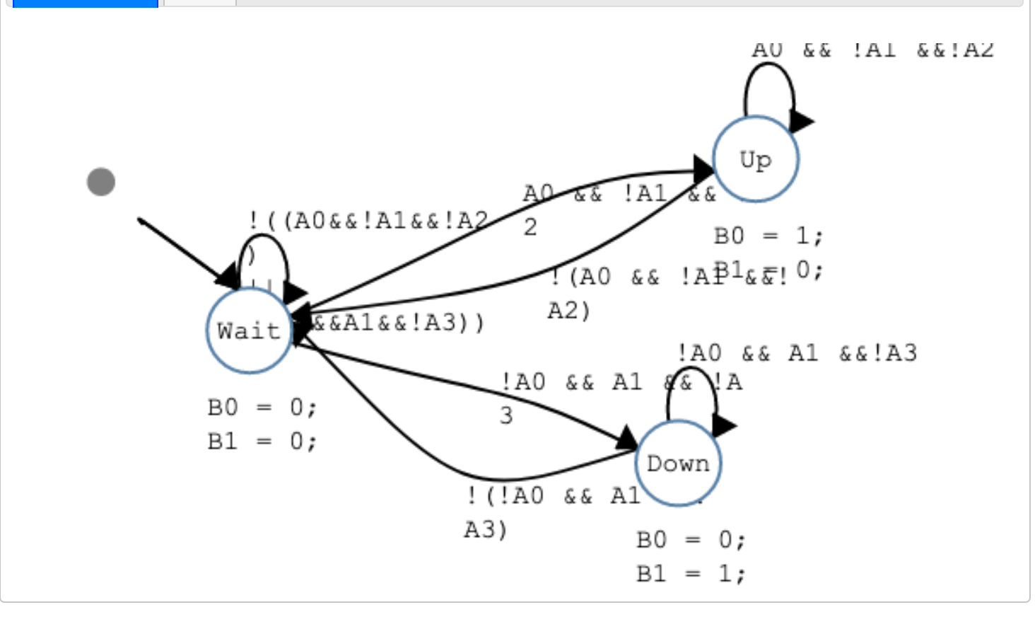

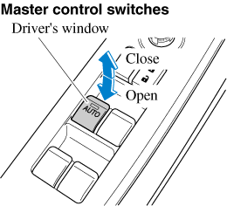

Synchronous State Machine -- synchSM

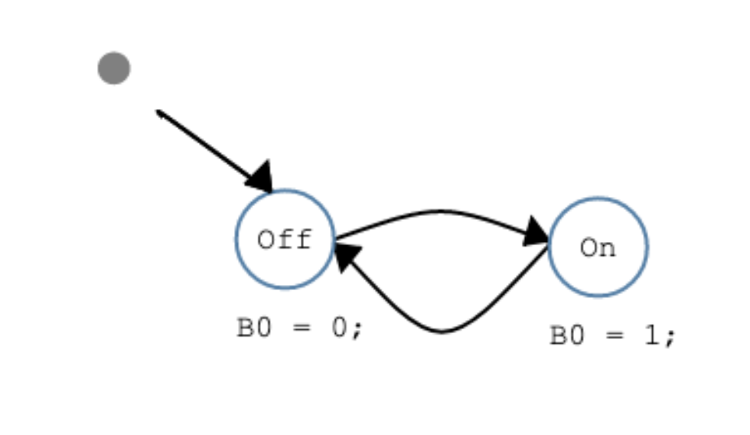

{"globalCode":"","graphs":[{"name":"LoHi","prefix":"SM1","period":1000,"localCode":"","nodes":[{"id":"node_0","x":53.25,"y":32.850006103515625,"name":"SMStart","init":false,"dummy":true,"actions":""},{"id":"node_1","x":140.75,"y":120.35000610351562,"name":"Off","init":true,"dummy":false,"actions":"B0 = 0;"},{"id":"node_2","x":300.75,"y":124.35000610351562,"name":"On","init":false,"dummy":false,"actions":"B0 = 1;"}],"edges":[{"id":"edge_0","src":"node_0","dst":"node_1","priority":1,"actions":"","condition":"","bp1":{"x":103.25,"y":82.85000610351562},"bp2":{"x":97,"y":76.60000610351562},"bp3":{"x":97,"y":76.60000610351562},"bp4":{"x":150.75,"y":130.35000610351562}},{"id":"edge_1","src":"node_1","dst":"node_2","priority":0,"actions":"","condition":"A0","bp1":{"x":190.75,"y":145.35000610351562},"bp2":{"x":245.81635257716812,"y":126.06376671494681},"bp3":{"x":245.81635257716812,"y":126.06376671494681},"bp4":{"x":300.88270515433624,"y":146.777527326378}},{"id":"edge_2","src":"node_2","dst":"node_1","priority":0,"actions":"","condition":"","bp1":{"x":300.75,"y":148.35000610351562},"bp2":{"x":245.7203791052873,"y":207.71003224870785},"bp3":{"x":245.7203791052873,"y":207.71003224870785},"bp4":{"x":190.6907582105746,"y":147.07005839390007}},{"id":"edge_3","src":"node_1","dst":"node_1","priority":1,"actions":"","condition":"!A0","bp1":{"x":165.75,"y":145.35000610351562},"bp2":{"x":140.75,"y":70.35000610351562},"bp3":{"x":200.75,"y":75.35000610351562},"bp4":{"x":185.75,"y":130.35000610351562}}]}]}

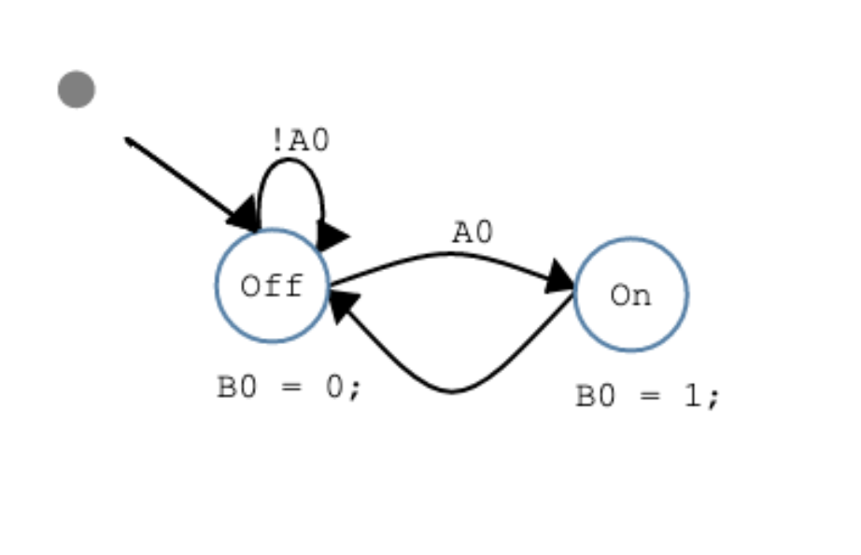

Add crazy blink: short on 500, 500 off, short on 500, 500 off, long on 1000, off 1000, repeat

{"globalCode":"","graphs":[{"name":"LoHi","prefix":"SM1","period":500,"localCode":"","nodes":[{"id":"node_0","x":13.25,"y":-9.149993896484375,"name":"SMStart","init":false,"dummy":true,"actions":""},{"id":"node_1","x":100.75,"y":78.35000610351562,"name":"Off","init":true,"dummy":false,"actions":"B0 = 0;"},{"id":"node_2","x":221.75,"y":16.350006103515625,"name":"ShortOn1","init":false,"dummy":false,"actions":"B0 = 1;"},{"id":"node_3","x":317.75,"y":16.350006103515625,"name":"ShortOff1","init":false,"dummy":false,"actions":"B0 = 0;"},{"id":"node_4","x":423.75,"y":18.350006103515625,"name":"ShortOn2","init":false,"dummy":false,"actions":"B0 = 1;"},{"id":"node_5","x":424.75,"y":108.35000610351562,"name":"ShortOff2","init":false,"dummy":false,"actions":"B0 = 0;"},{"id":"node_6","x":426.75,"y":221.35000610351562,"name":"LongOn1","init":false,"dummy":false,"actions":"B0 = 1;"},{"id":"node_7","x":298.75,"y":222.35000610351562,"name":"LongOn2","init":false,"dummy":false,"actions":"B0 = 1;"},{"id":"node_8","x":178.75,"y":208.35000610351562,"name":"LongOff1","init":false,"dummy":false,"actions":"B0 = 0;"}],"edges":[{"id":"edge_0","src":"node_0","dst":"node_1","priority":1,"actions":"","condition":"","bp1":{"x":63.25,"y":40.850006103515625},"bp2":{"x":57,"y":34.600006103515625},"bp3":{"x":57,"y":34.600006103515625},"bp4":{"x":110.75,"y":88.35000610351562}},{"id":"edge_1","src":"node_1","dst":"node_1","priority":1,"actions":"","condition":"!A0","bp1":{"x":125.75,"y":103.35000610351562},"bp2":{"x":100.75,"y":28.350006103515625},"bp3":{"x":160.75,"y":33.350006103515625},"bp4":{"x":145.75,"y":88.35000610351562}},{"id":"edge_2","src":"node_1","dst":"node_2","priority":0,"actions":"","condition":"A0","bp1":{"x":150.75,"y":90.35000610351562},"bp2":{"x":182.75,"y":80.35000610351562},"bp3":{"x":181.75,"y":125.35000610351562},"bp4":{"x":224.23620909088555,"y":52.21873274929503}},{"id":"edge_3","src":"node_2","dst":"node_3","priority":0,"actions":"","condition":"","bp1":{"x":271.75,"y":41.350006103515625},"bp2":{"x":294.7796208947127,"y":102.21003224870785},"bp3":{"x":294.7796208947127,"y":102.21003224870785},"bp4":{"x":317.8092417894254,"y":43.07005839390008}},{"id":"edge_4","src":"node_3","dst":"node_4","priority":0,"actions":"","condition":"","bp1":{"x":366.75,"y":41.350006103515625},"bp2":{"x":395.3163525771681,"y":21.06376671494681},"bp3":{"x":395.3163525771681,"y":21.06376671494681},"bp4":{"x":423.88270515433624,"y":40.77752732637799}},{"id":"edge_5","src":"node_4","dst":"node_5","priority":0,"actions":"","condition":"","bp1":{"x":448.75,"y":68.35000610351562},"bp2":{"x":450.63039407593556,"y":68.4264594200954},"bp3":{"x":450.63039407593556,"y":68.4264594200954},"bp4":{"x":452.51078815187117,"y":108.50291273667516}},{"id":"edge_6","src":"node_5","dst":"node_6","priority":0,"actions":"","condition":"","bp1":{"x":449.75,"y":158.35000610351562},"bp2":{"x":448.4738842477211,"y":170.05898104120988},"bp3":{"x":448.4738842477211,"y":170.05898104120988},"bp4":{"x":447.1977684954423,"y":221.76795597890413}},{"id":"edge_7","src":"node_6","dst":"node_7","priority":0,"actions":"","condition":"","bp1":{"x":426.75,"y":246.35000610351562},"bp2":{"x":387.7425749919198,"y":307.28078455151285},"bp3":{"x":387.7425749919198,"y":307.28078455151285},"bp4":{"x":348.7351499838397,"y":248.2115629995101}},{"id":"edge_8","src":"node_7","dst":"node_8","priority":0,"actions":"","condition":"","bp1":{"x":298.75,"y":244.35000610351562},"bp2":{"x":263.62436867076457,"y":300.617773056482},"bp3":{"x":263.62436867076457,"y":300.617773056482},"bp4":{"x":228.49873734152916,"y":236.88554000944836}},{"id":"edge_9","src":"node_8","dst":"node_1","priority":0,"actions":"","condition":"","bp1":{"x":188.75,"y":208.35000610351562},"bp2":{"x":164.44366757718268,"y":226.0725863447752},"bp3":{"x":164.44366757718268,"y":226.0725863447752},"bp4":{"x":140.13733515436533,"y":123.79516658603478}}]}]}



* Thu lect:

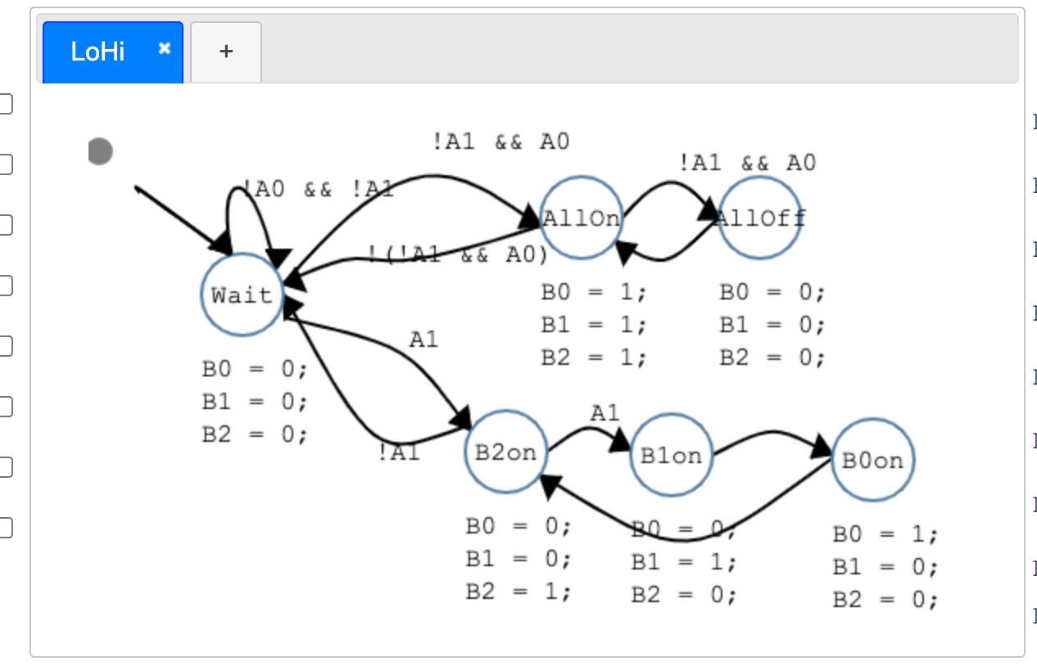

{"globalCode":"","graphs":[{"name":"LoHi","prefix":"SM1","period":1000,"localCode":"","nodes":[{"id":"node_0","x":-17.75,"y":-3.649993896484375,"name":"SMStart","init":false,"dummy":true,"actions":""},{"id":"node_1","x":69.75,"y":83.85000610351562,"name":"Wait","init":true,"dummy":false,"actions":"B0 = 0;\nB1 = 0;\nB2 = 0;"},{"id":"node_2","x":276.75,"y":36.850006103515625,"name":"AllOn","init":false,"dummy":false,"actions":"B0 = 1;\nB1 = 1;\nB2 = 1;"},{"id":"node_3","x":230.75,"y":179.85000610351562,"name":"B2on","init":false,"dummy":false,"actions":"B0 = 0;\nB1 = 0;\nB2 = 1;"},{"id":"node_4","x":331.75,"y":181.85000610351562,"name":"B1on","init":false,"dummy":false,"actions":"B0 = 0;\nB1 = 1;\nB2 = 0;"},{"id":"node_5","x":454.75,"y":184.85000610351562,"name":"B0on","init":false,"dummy":false,"actions":"B0 = 1;\nB1 = 0;\nB2 = 0;"},{"id":"node_6","x":385.75,"y":36.850006103515625,"name":"AllOff","init":false,"dummy":false,"actions":"B0 = 0;\nB1 = 0;\nB2 = 0;"}],"edges":[{"id":"edge_0","src":"node_0","dst":"node_1","priority":1,"actions":"","condition":"","bp1":{"x":32.25,"y":46.350006103515625},"bp2":{"x":26,"y":40.100006103515625},"bp3":{"x":26,"y":40.100006103515625},"bp4":{"x":79.75,"y":93.85000610351562}},{"id":"edge_1","src":"node_1","dst":"node_1","priority":1,"actions":"","condition":"!A0 && !A1","bp1":{"x":94.75,"y":108.85000610351562},"bp2":{"x":69.75,"y":33.850006103515625},"bp3":{"x":98.75,"y":14.850006103515625},"bp4":{"x":114.75,"y":93.85000610351562}},{"id":"edge_2","src":"node_1","dst":"node_2","priority":0,"actions":"","condition":"!A1 && A0","bp1":{"x":119.75,"y":102.85000610351562},"bp2":{"x":195.75,"y":11.850006103515625},"bp3":{"x":220.75,"y":26.850006103515625},"bp4":{"x":277.44794478566786,"y":67.71601943111305}},{"id":"edge_3","src":"node_1","dst":"node_3","priority":0,"actions":"","condition":"A1","bp1":{"x":119.75,"y":122.85000610351562},"bp2":{"x":195.62572348071222,"y":139.51863345161757},"bp3":{"x":195.62572348071222,"y":139.51863345161757},"bp4":{"x":233.9994453537847,"y":192.52469180399362}},{"id":"edge_4","src":"node_2","dst":"node_6","priority":0,"actions":"","condition":"!A1 && A0","bp1":{"x":326.75,"y":61.850006103515625},"bp2":{"x":353.75,"y":27.51666259765625},"bp3":{"x":363.75,"y":36.51666259765625},"bp4":{"x":385.8092417894254,"y":63.57005839390008}},{"id":"edge_5","src":"node_6","dst":"node_2","priority":1,"actions":"","condition":"","bp1":{"x":385.75,"y":61.850006103515625},"bp2":{"x":353.75,"y":89.51666259765625},"bp3":{"x":353.75,"y":95.51666259765625},"bp4":{"x":322.48930405481065,"y":75.80999418811345}},{"id":"edge_6","src":"node_2","dst":"node_1","priority":0,"actions":"","condition":"!(!A1 && A0)","bp1":{"x":276.75,"y":66.85000610351562},"bp2":{"x":138.75,"y":111.51666259765625},"bp3":{"x":197.7999077275759,"y":64.52589362694296},"bp4":{"x":118.84981545515184,"y":102.2017811503703}},{"id":"edge_7","src":"node_3","dst":"node_4","priority":0,"actions":"","condition":"A1","bp1":{"x":280.75,"y":204.85000610351562},"bp2":{"x":306.31203512237516,"y":184.60620961575313},"bp3":{"x":306.31203512237516,"y":184.60620961575313},"bp4":{"x":331.87407024475027,"y":204.36241312799066}},{"id":"edge_8","src":"node_4","dst":"node_5","priority":0,"actions":"","condition":"","bp1":{"x":381.75,"y":206.85000610351562},"bp2":{"x":418.3163525771681,"y":187.0637667149468},"bp3":{"x":418.3163525771681,"y":187.0637667149468},"bp4":{"x":454.88270515433624,"y":207.277527326378}},{"id":"edge_9","src":"node_5","dst":"node_3","priority":1,"actions":"","condition":"","bp1":{"x":454.75,"y":208.85000610351562},"bp2":{"x":365.6196520274053,"y":273.83000014581455},"bp3":{"x":365.6196520274053,"y":273.83000014581455},"bp4":{"x":276.48930405481065,"y":218.80999418811345}},{"id":"edge_10","src":"node_3","dst":"node_1","priority":2,"actions":"","condition":"!A1","bp1":{"x":229.75,"y":189.85000610351562},"bp2":{"x":174.7476398601202,"y":209.10711121527194},"bp3":{"x":174.7476398601202,"y":209.10711121527194},"bp4":{"x":119.74527972024039,"y":108.36421632702826}}]}]}

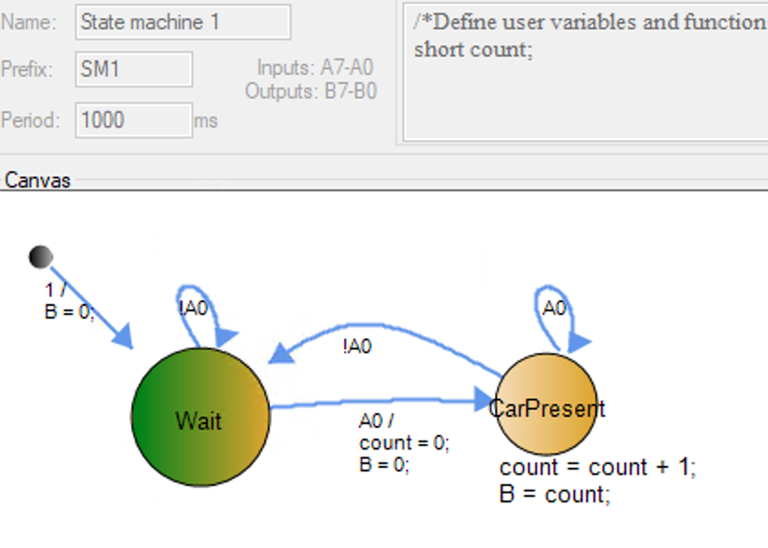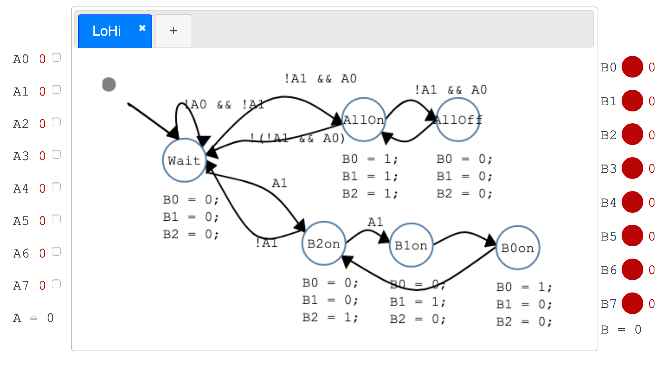

WK4

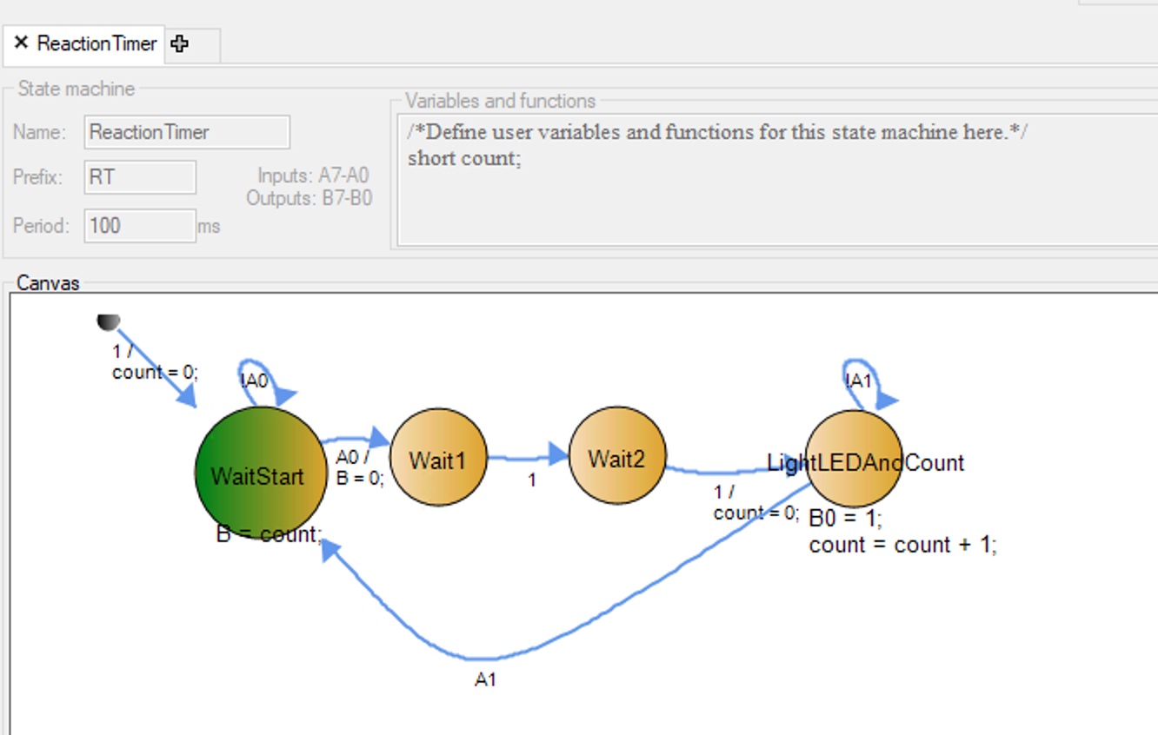



Thu

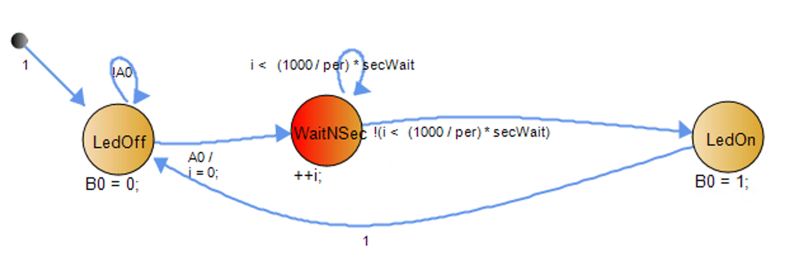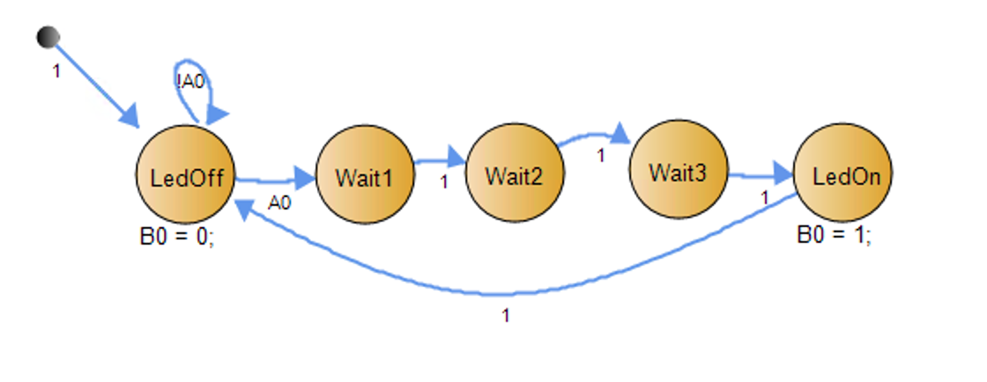

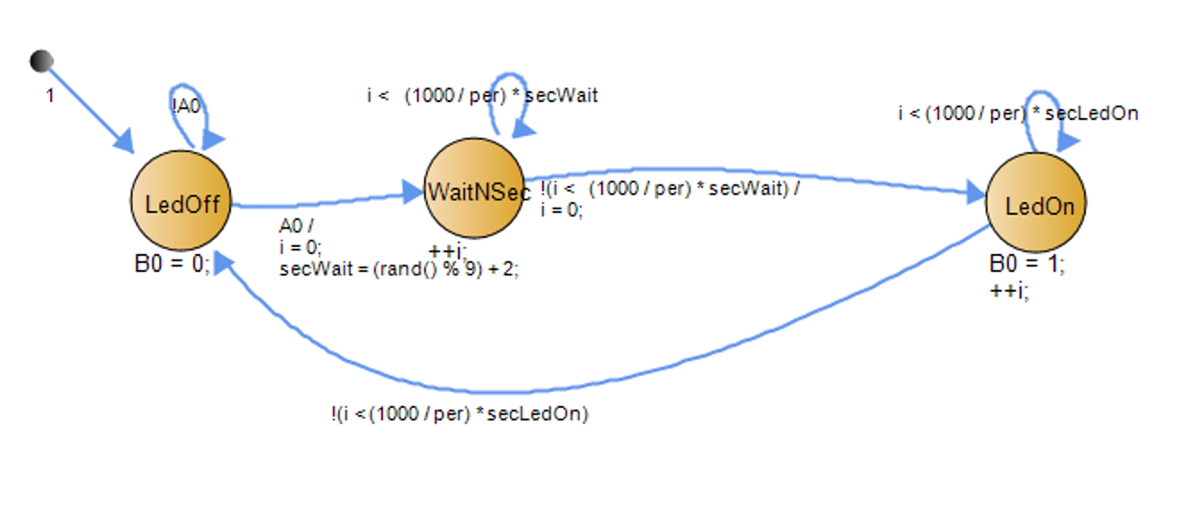

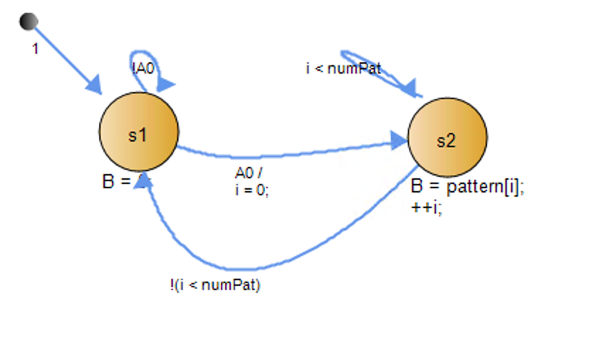

# WK5

Tu

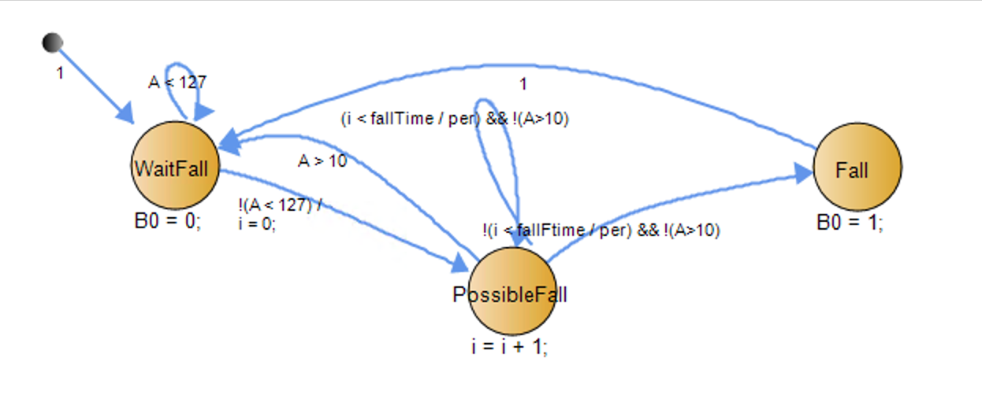

/*

This code was automatically generated using the Riverside-Irvine State machine Builder tool

Version 2.8 --- 4/27/2021 13:40:21 PST

*/

#include "rims.h"

/*This code will be shared between state machines.*/

unsigned char TimerFlag = 0;

void TimerISR() {

TimerFlag = 1;

}

enum SM1_States { SM1_s3, SM1_s4, SM1_s5 } SM1_State;

TickFct_ThreeLEDs() {

switch(SM1_State) { // Transitions

case -1:

SM1_State = SM1_s3;

break;

case SM1_s3:

if (1) {

SM1_State = SM1_s4;

}

break;

case SM1_s4:

if (1) {

SM1_State = SM1_s5;

}

break;

case SM1_s5:

if (1) {

SM1_State = SM1_s3;

}

break;

default:

SM1_State = SM1_s3;

} // Transitions

switch(SM1_State) { // State actions

case SM1_s3:

B5 = 1;

B6 = 0;

B7 = 0;

break;

case SM1_s4:

B5 = 0;

B6 = 1;

B7 = 0;

break;

case SM1_s5:

B5 = 0;

B6 = 0;

B7 = 1;

break;

default: // ADD default behaviour below

break;

} // State actions

}

enum SM2_States { SM2_Blink } SM2_State;

TickFct_B0Blink() {

/*VARIABLES MUST BE DECLARED STATIC*/

/*e.g., static int x = 0;*/

/*Define user variables for this state machine here. No functions; make them global.*/

switch(SM2_State) { // Transitions

case -1:

B0 = 0;

SM2_State = SM2_Blink;

break;

case SM2_Blink:

if (1) {

SM2_State = SM2_Blink;

}

break;

default:

SM2_State = SM2_Blink;

} // Transitions

switch(SM2_State) { // State actions

case SM2_Blink:

B0 = !B0;

break;

default: // ADD default behaviour below

break;

} // State actions

}

int main() {

B = 0; //Init outputs

TimerSet(1000);

TimerOn();

SM1_State = -1;

SM2_State = -1;

while(1) {

TickFct_ThreeLEDs();

TickFct_B0Blink();

while (!TimerFlag);

TimerFlag = 0;

}

}

Thu

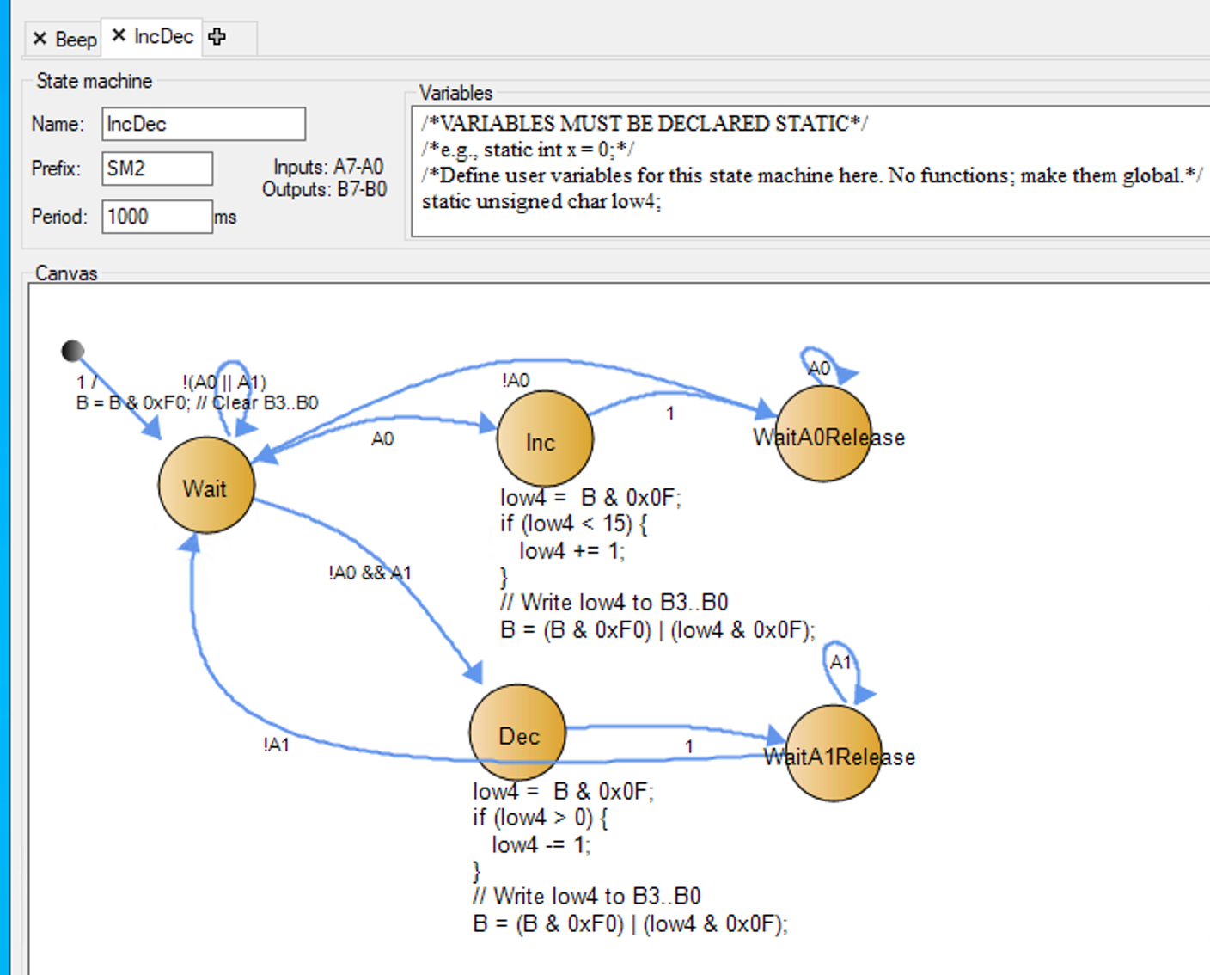

// Write low4 to B3..B0

B = (B & 0xF0) | (low4 & 0x0F);

11000000 | 00000100 --> 11000100

B = B | (low4 & 0x0F)

11000011 | 00000100 --> 11000111

// B 1100 0011

// B 1100 0100

# WK6

Tu

Simplified SM

#include "RIMS.h"

volatile int TimerFlag = 0;

void TimerISR() {

TimerFlag = 1;

}

enum SM1_STATES { SM1_SMStart, SM1_Wait1, SM1_Wait0} SM1_STATE;

void Tick_LoHi() {

switch(SM1_STATE) {

case SM1_SMStart:

SM1_STATE = SM1_Wait1;

B = 0;

break;

case SM1_Wait1:

if (!A0) {

SM1_STATE = SM1_Wait1;

}

else {

SM1_STATE = SM1_Wait0;

B = B + 1;

}

break;

case SM1_Wait0:

if (A0) {

SM1_STATE = SM1_Wait0;

}

else {

SM1_STATE = SM1_Wait1;

}

break;

default:

SM1_STATE = SM1_Wait1;

break;

}

}

int main(){

int LoHiElapsedTime = 1000;

int periodGCD = 1000;

TimerSet(periodGCD);

TimerOn();

while(1){

if (LoHiElapsedTime >= 1000){

Tick_LoHi();

LoHiElapsedTime = 0;

}

LoHiElapsedTime += 1000;

while(!TimerFlag);

TimerFlag=0;

}

}

#include "RIMS.h"

unsigned char TimerFlag = 0;

void TimerISR() {

TimerFlag = 1;

}

void TickFct_Task1() { // Every 1 sec

B0 = !B0;

}

void TickFct_Task2() { // Every 2 sec

B2 = !B2;

}

int main() {

int counter;

B = 0; //Init outputs

TimerSet(1000);

TimerOn();

counter = 0;

while(1) {

TickFct_Task1();

TickFct_Task2();

Sleep();

while (!TimerFlag);

TimerFlag = 0;

}

}

Choices: Home, dorm, apartment

Metrics: Price, commute time, comfort/enjoyment, privacy, convenience, safety

Very good Good Mid Bad Very bad

|  |  |  |  |  |  |  |
| --- | --- | --- | --- | --- | --- | --- |
| Choice/Metric | Price | Commute time | Comfort/enjoyment | Privacy | Convenience | Safety |
| Home | VG | B | B |  |  |  |
| Dorm | B | VG | VB |  |  |  |
| Apartment | M | G | G |  |  |  |

Home is inexpensive but has long commute time and is not enjoyable due to my dog keeps biting me.

Dorm ....

For me time is very tight and has the highest weight. So I need to live near campus to have time to study. Dorms for me are too loud and distracting. So I'm going with Apartment.

Fall detector

|  |  |  |  |  |
| --- | --- | --- | --- | --- |
| Choices | Price | Use/Accessibility | Accuracy | Coverage |
| Necklace | M | B | G | VG |
| Watch | B | M | G | VG |
| Wall mounted | G | VG | M | B |

bottom